**Name: Riya Jacey Kurian**

**Roll No:29**

**Batch: RMCA(B)**

**Date:19/04/2022**

**EXPERIMENT NO. 4**

**AIM**

To familiarize with aggregate functions

**QUESTION**

1.List total loan

2.List total deposit

3.List total loan taken from KAROLBAGH branch

4.List total deposit of customers having account date later than 1-Jan-96

5.List total deposit of customers living in city NAGPUR

6.List maximum deposit of customer living in Bombay

7.List total deposit of customer having branch in BOMBAY

8.Count total number of branch cities

9.Count total number of customers cities

10.Give branch names and branch wise deposit

11.Give city wise name and branch wise deposit

12.Give the branch wise loan of customer living in NAGPUR

13.Count total number of customers

14.Count total number of depositors branch wise

15.Count total number of depositors branch wise

16.Give maximum loan from branch VRCE

17.Give the number of customers who are depositors as well as borrowers

**PROCEDURE**

1. SELECT SUM(AMOUNT) FROM BORROW;

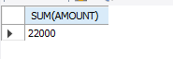

 2. SELECT SUM(AMOUNT) FROM DEPOSIT;

D:\RIYA DBMS\exp 4\4.2.png

3. SELECT MAX(AMOUNT) FROM BORROW WHERE BNAME ='KAROLBAGH';

D:\RIYA DBMS\exp 4\4.3.png

4. SELECT SUM(AMOUNT) from deposit where adate>'1995-03-01';

D:\RIYA DBMS\exp 4\4.4.png

5. SELECT SUM(D1.AMOUNT) FROM DEPOSIT D1 , CUSTOMER C1 WHERE  C1.CITY = 'NAGPUR' AND C1.CNAME = D1.CNAME;

D:\RIYA DBMS\exp 4\4.5.png

6. SELECT MAX(D1.AMOUNT) FROM DEPOSIT D1 , CUSTOMER C1 WHERE  C1.CITY = 'Bombay' AND C1.CNAME = D1.CNAME;

D:\RIYA DBMS\exp 4\4.6.png

7. SELECT SUM(AMOUNT) from deposit,BRANCH where city='BOMBAY';

D:\RIYA DBMS\exp 4\4.7.png

8. SELECT COUNT(DISTINCT(CITY)) FROM BRANCH ;

D:\RIYA DBMS\exp 4\4.8.png

9.  SELECT count(city) from CUSTOMER;

D:\RIYA DBMS\exp 4\4.9.png

10. SELECT BNAME , SUM(AMOUNT) FROM DEPOSIT GROUP BY BNAME;

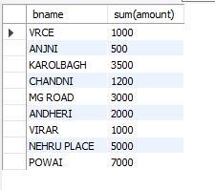

11. SELECT C1.CITY , SUM(D1.AMOUNT) FROM CUSTOMER C1 , DEPOSIT D1  WHERE D1.CNAME = C1.CNAME GROUP BY C1.CITY;

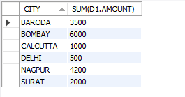

12. SELECT BNAME , SUM(AMOUNT) FROM BORROW,CUSTOMER WHERE city  ='NAGPUR' GROUP BY BNAME;

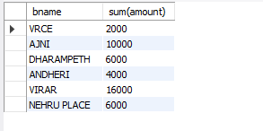

13.  SELECT count(cname) from CUSTOMER;

D:\RIYA DBMS\exp 4\4.13.png

14.  select BName, count(*) from DEPOSIT, CUSTOMER where deposit.CNAME =  CUSTOMER.CNAME group by BNAME;

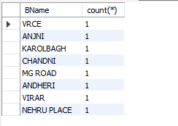

15.  select BName, count(*) from DEPOSIT, CUSTOMER where deposit.CNAME =  CUSTOMER.CNAME group by BNAME;

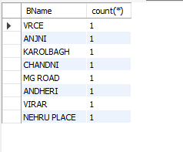

16. SELECT MAX(AMOUNT) FROM BORROW WHERE BNAME ='VRCE';

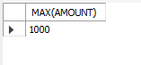

17. SELECT COUNT(DISTINCT(B1.CNAME)) FROM BORROW B1, DEPOSIT D1 WHERE B1.CNAME IN (SELECT CNAME FROM DEPOSIT);

